Chad

## GNI per capita and development level

The data set shows the GNI per capita and development level of the country each year.

## # A tibble: 19 x 5  
## country iso3c date GNIperCapita devCategory   
## <chr> <chr> <dbl> <dbl> <chr>   
## 1 Chad TCD 1996 24868. High Income   
## 2 Chad TCD 1998 25497. High Income   
## 3 Chad TCD 2000 40066. High Income   
## 4 Chad TCD 2002 2197. Lower Middle Income  
## 5 Chad TCD 2003 532. Low Income   
## 6 Chad TCD 2004 2197. Lower Middle Income  
## 7 Chad TCD 2005 361. Low Income   
## 8 Chad TCD 2006 592. Low Income   
## 9 Chad TCD 2007 696. Low Income   
## 10 Chad TCD 2008 673. Low Income   
## 11 Chad TCD 2009 778. Low Income   
## 12 Chad TCD 2010 863. Low Income   
## 13 Chad TCD 2011 842. Low Income   
## 14 Chad TCD 2012 887. Low Income   
## 15 Chad TCD 2013 886. Low Income   
## 16 Chad TCD 2014 919. Low Income   
## 17 Chad TCD 2015 932. Low Income   
## 18 Chad TCD 2016 856. Low Income   
## 19 Chad TCD 2017 809. Low Income

## GDP growth and economic growth classification

The data set shows the GDP growth and the ecomic growth classification of the country each year.

## # A tibble: 19 x 5  
## country iso3c date GDPannualGrowthRate GDPgrowthCategory4  
## <chr> <chr> <dbl> <dbl> <fct>   
## 1 Chad TCD 1996 2.21 slow growth   
## 2 Chad TCD 1998 6.95 fast growth   
## 3 Chad TCD 2000 -0.880 negative grwoth   
## 4 Chad TCD 2002 8.49 fast growth   
## 5 Chad TCD 2003 14.7 fast growth   
## 6 Chad TCD 2004 33.6 fast growth   
## 7 Chad TCD 2005 17.3 fast growth   
## 8 Chad TCD 2006 0.648 slow growth   
## 9 Chad TCD 2007 3.27 moderate growth   
## 10 Chad TCD 2008 3.05 moderate growth   
## 11 Chad TCD 2009 4.22 moderate growth   
## 12 Chad TCD 2010 13.6 fast growth   
## 13 Chad TCD 2011 0.0829 slow growth   
## 14 Chad TCD 2012 8.88 fast growth   
## 15 Chad TCD 2013 5.70 fast growth   
## 16 Chad TCD 2014 6.90 fast growth   
## 17 Chad TCD 2015 2.77 moderate growth   
## 18 Chad TCD 2016 -6.26 negative grwoth   
## 19 Chad TCD 2017 -2.99 negative grwoth

## Development trend

The plot shows the development trend of the country.

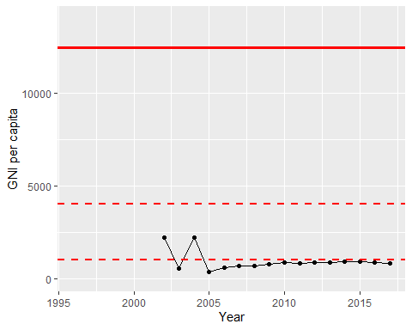

GNI Per Capita Trend